Lab 1 Introduction to MS Access
Summary
- What is Microsoft Access?
- Ways to get help
- MS Access: Overview
- Table, Query, Form, Report
- Terminology
1. MS Access
In this lab, we will be implementing the theories on database design that we learned in class with a program called Microsoft Access (MS Access). MS Access is a commercial Relational Database Management System (RDBMS) from Microsoft. It sells for at least $160 (stand alone) if you do a price search online and is included in MS Office Professional. However, the university computer store has a bargain available for students. The whole package for Microsoft Office 2003 Professional Student License for Windows, including MS Access is priced around $80. Here is the link to the website. http://calcomputers.berkeley.edu/. If you have a laptop, you are encouraged to get Access installed on you computer and bring your laptop to the lab session since we only have less than 20 computers in the room.

If you do not have a copy of MS Access on your home PC, you can launch it on any of our lab machines with StartAll ProgramsMicrosoft Access OR clicking the icon on the office toolbar. To use the lab machines, you will need to have a Windows NT account within the IEOR Department. To obtain more information on how to set up your account, please visit:
http://www.ieor.berkeley.edu/labs/lab.htm

Most of the information given out in this lab can be accessed in greater detail under Microsoft Access’s extensive help files. We will start by giving an introduction to MS Access and then we will be discussing ways to access help files in Microsoft Access. All the information provided in this tutorial is based on MS Access 2002 unless specified otherwise. If you have a different version installed on your machine, you should expect to see some minor difference between what is described here and what you observe on your screen.

Database Window
- When you open a new or existing database, you will be greeted by the database window
- Use it to conveniently access all components of MS Access. For example click the tab Tables under Objects to view a list of the available tables in the database and also the shortcuts for creating new tables.
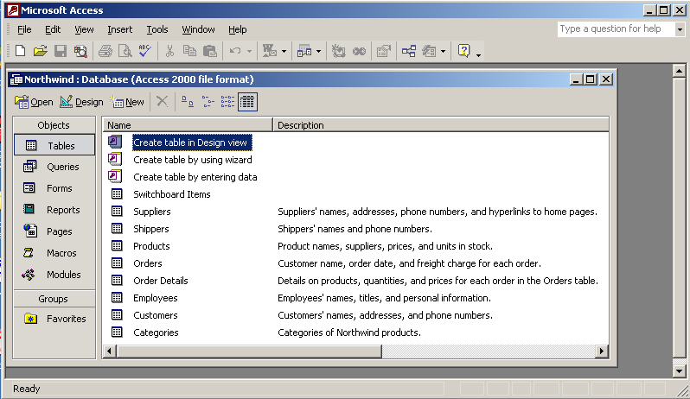
Fig. 1 Database Window
What is a database?

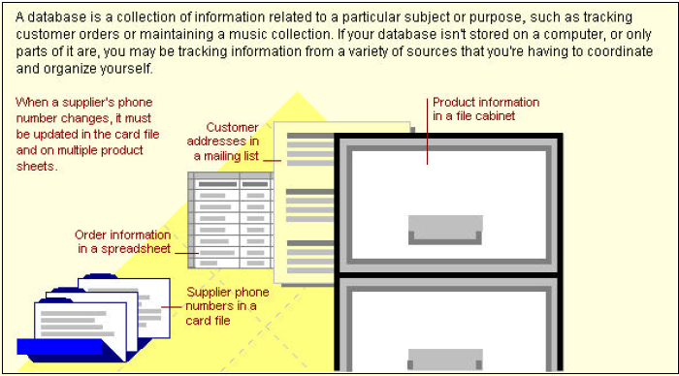

2. Ways to get help

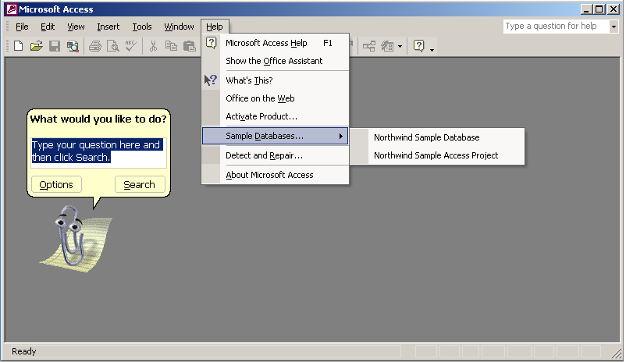
Fig. 2 Help Menu and Office Assistant

- Type your question in the box on the top right corner of the Access window.
- Similar to MS Word, you can get help by pressing F1 key or clicking Microsoft Access Help on the Help menu. If the Office Assistant is turned off, MS Access Help window appears; otherwise the Office Assistant appears. To turn off assistant, click the Assistant, and then click Options. On the Options tab, clear the Use the Office Assistant check box.

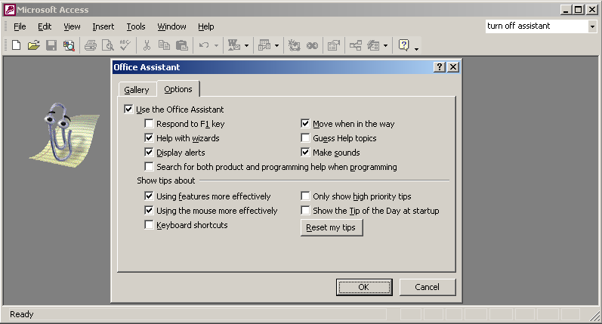
Fig. 3 Office Assistant Menu

- In MS Access Help window, to scroll through a table of contents for Help, click the Contents tab; to type a question in the Help window, click the Answer Wizard tab; to search for specific words or phrases, click the Index tab. To get help on the topics discussed in this particular lab, we will go to the Microsoft Access HelpContents Getting Started  “Using a database for the first time”, as shown:

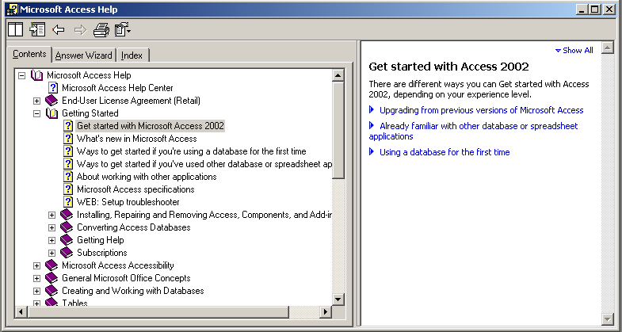
Fig. 4 Microsoft Access Help Window

- If the Office Assistant appears with “What would you like to do”, just type your question as prompted. If you want to turn the office
3. MS Access Overview
- Microsoft Access’s Components: Tables, Queries, Forms, Reports, Pages, Macros, Modules
- Each has its own special function to allow the user to manage information

Table
- A table allows the user to store a collection of data about a specific topic like Customers or Orders
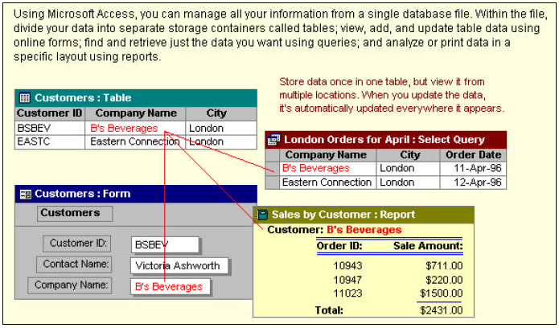

Query
- A query allows the user to view, change, and analyze data in different ways like combining data from two different tables (Customers and Orders) to create a user’s own custom view (London Orders for April)
- Can also be used as the source of records for forms, reports, and data access pages.

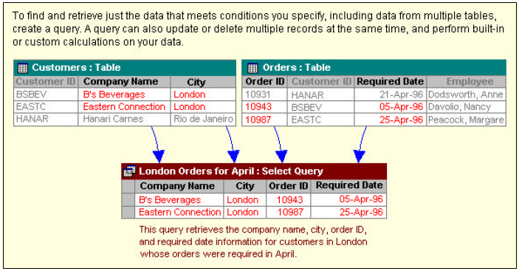

Form
- A form allows a user to enter/change/update data to table(s)
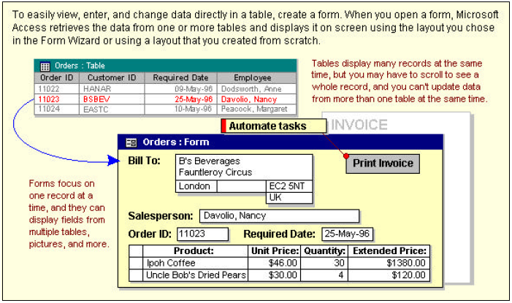
Report
• A report is an effective way to output your data in a printed format in the way you want it
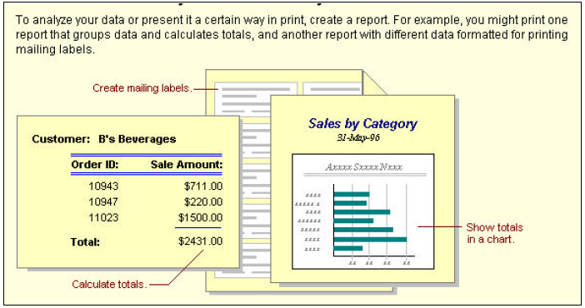
4. Terminology
Note that MS Access sometimes uses terms that differ from those used in class and the textbook.
MS Access | Lecture/Text
Table (Lab 3) | Relation (Ch. 5)
Column/Field (Lab 3) | Attribute (Ch. 3)
Row/Record (Lab 3) | Tuple (Ch. 5)
Relationship View (Lab 4) | Lines indicate foreign keys (Ch. 7)

Quiz 1

(Due at start of next class)

Open Northwind database by clicking HelpSample DatabasesNorthwind Sample Database and answer the following questions:

1. What version of Access do you have?

2. Please list different objects or components available in the Northwind Database window? Describe two of them in simple words in terms of their functions.

3. In TABLE Shippers, how many shippers are there? Please list them.

4. In TABLE Orders, which field (i.e. column heading) is identical to the field in TABLE Employees? and TABLE Customers ? and TABLE Shippers ? Please list all you can find in the format like Orders.field1=Employees.field2, and etc. (Clarification: consider the identity in terms of contents but not the field names, and allow combination of fields in the same table, for example Orders.fieldnameX= Employees.fieldnameY+ Employee.fieldnameZ)

5. Find the order with the most expensive freight, and list the Order ID and freight charges.

6. What are the seven options available in the FORM: Main Switchboard?

7. What is the dollar amount of products ordered by B’s Beverages (CustomerID=BSBEV) during the 1st Quarter of 1997? What is the TOTAL dollar amount ordered by B’s Beverages in 1997? (Hint: find the relevant form first)

8. How many orders have been shipped in 1997? What’s the total sales revenue in 1997? (Hint: find the relevant report first)

Note that the Relationship View in MS Access looks similar but is different from ER Diagram.

